Music Editor
It is a program that allows your write your own Music on Matlab and Play it…

- Install
(1.1)
I have provided a app package that allows you install it on the matlab and find it in MY APPS
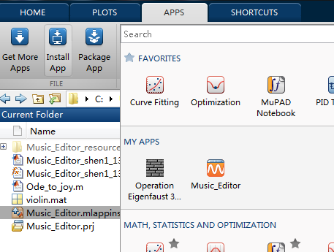
And run it like a real program other than a m.file….

(1.2)
If you wish, you can also run the Music_Editor_shen1_1386326.m
DO NOT DIRECTELY DOUBLE CLINK “ .fig” FILE TO RUN IT.
IT WILL NEVER WORK
- Background knowledge…
Well…If you want to write a music, you have to know how to write a note..
Matlab does not provide a function that allows me to show the melody like this..
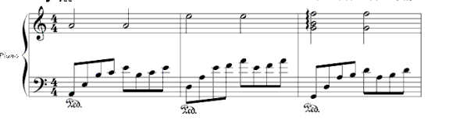
So you have to write them in characters…

According to Wiki…
http://en.wikipedia.org/wiki/Note
And my simply modified.

You can find the note provided in the following table

3th octave
 | la | ti | do | re | mi | fa | so
1/4 | a3q | b3q | c3q | d3q | e3q | f3q | g3q
1/8 | a3e | b3e | c3e | d3e | e3e | f3e | g3e
1/16 | a3s | b3s | c3s | d3s | e3s | fs | g3s
4th octave
 | la | ti | do | re | mi | fa | so
1/4 | a4q | b4q | c4q | d4q | e4q | f4q | g4q
1/8 | a4e | b4e | c4e | d4e | e4e | f4e | g4e
1/16 | a4s | b4s | c4s | d4s | e4s | f4s | g4s
5th octave
 | la | ti | do | re | mi | fa | so
1/4 | a5q | b5q | c5q | d5q | e5q | f5q | g5q
1/8 | a5e | b5e | c5e | d5e | e5e | f5e | g5e
1/16 | a5s | b5s | c5s | d5s | e5s | f5s | g5s

If you want to create a period of blank, in other word, pause for a few second.
Use blq to replace 1/4 note
Use ble to replace 1/8 note
Use bls to replace 1/16 note
Example
This melody only plays a 1/8 note do in 3th octave
But before you hear that , it pauses for the time of 2 1/8 note.
- Grammar
If you are creating a new melody.
Start writing at the very beginning of the script.
Add a single space between every notes.eg:
If you are combining an ensemble
Just place the notes you write on the same vertical line.no more no less
Example
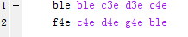
NOTE: in this situation there will be a space at the very beginning of each line
NOTE: NEVER ENTER A SAPCE AT THE END OF LINE, AND NEVER LEAVE A BLANK WHEN THERE SHOULD BE A NOTE
Error presentation:
- Leave a blank
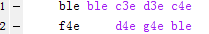
- Not in vertical line
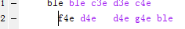

- I have provided a sample melody (Ode_to_joy.m) created by this program
So if you don’t know how to test, this might help.
To listen this melody
- Run the program
- Enter the name in the edit text above the “play” button
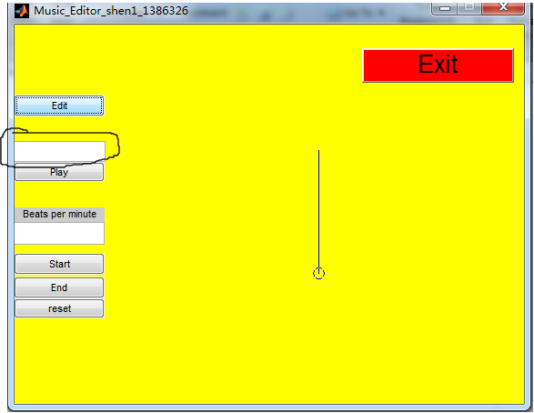

- Press “play’
- Press ”Yes”
- Enter “3”
- Engjoy

